LAB ASSIGNMENT-7

|  |
| --- |
| CREATE TABLE SalesPeople( |
|  |

|  |
| --- |
| Snum number(10) PRIMARY KEY, |
|  |

|  |
| --- |
| Sname varchar2(30) UNIQUE, |
|  |

|  |
| --- |
| City varchar2(20), |
|  |

|  |
| --- |
| Comm number(20,2) |
|  |

|  |
| --- |
| ) |
|  |

|  |
| --- |
| INSERT INTO SalesPeople(Snum, Sname, City,Comm) |
|  |

|  |
| --- |
| VALUES(1001, 'Peel', 'London', 0.12) |
|  |

|  |
| --- |
| INSERT INTO SalesPeople VALUES( 1002, 'Serres', 'Sanjose',0.13) |
|  |

|  |
| --- |
| INSERT INTO SalesPeople VALUES(1004, 'Motika', 'London',0.11) |
|  |

|  |
| --- |
| INSERT INTO SalesPeople VALUES(1007, 'Rifkin', 'Barcelona',0.15) |
|  |

|  |
| --- |
| INSERT INTO SalesPeople VALUES(1003, 'Axelrod', 'Newyork',0.10) |
|  |

|  |
| --- |
| SELECT * FROM SalesPeople |
|  |

|  |
| --- |
|  |
|  |

|  |
| --- |
| CREATE TABLE Customers( |
|  |

|  |
| --- |
| Cnum number(10) PRIMARY KEY, |
|  |

|  |
| --- |
| Cname varchar2(30), |
|  |

|  |
| --- |
| City varchar2(20) NOT NULL, |
|  |

|  |
| --- |
| Snum number(20,2) |
|  |

|  |
| --- |
| ) |
|  |

|  |
| --- |
|  |
|  |

|  |
| --- |
| ALTER TABLE Customers |
|  |

|  |
| --- |
| ADD CONSTRAINT FK_Cust |
|  |

|  |
| --- |
| FOREIGN KEY(Snum) REFERENCES SalesPeople(Snum) |
|  |

|  |
| --- |
|  |
|  |

|  |
| --- |
| SELECT * FROM Customers |
|  |

|  |
| --- |
| INSERT INTO Customers VALUES(2001,'Hoffman','London',1001) |
|  |

|  |
| --- |
| INSERT INTO Customers VALUES(2002,'Giovanni','Rome',1003) |
|  |

|  |
| --- |
| INSERT INTO Customers VALUES(2003,'Liu','Sanjose',1002) |
|  |

|  |
| --- |
| INSERT INTO Customers VALUES(2004,'Grass','Berlin',1002) |
|  |

|  |
| --- |
| INSERT INTO Customers VALUES(2006,'Clemens','London',1001) |
|  |

|  |
| --- |
| INSERT INTO Customers VALUES(2008,'Cisneros','Sanjose',1007) |
|  |

|  |
| --- |
| INSERT INTO Customers VALUES(2007,'Pereira','Rome',1004) |
|  |

|  |
| --- |
| DELETE FROM Customers WHERE Cnum = 2001 |
|  |

|  |
| --- |
|  |
|  |

|  |
| --- |
| CREATE TABLE Orders( |
|  |

|  |
| --- |
| Onum number(10) PRIMARY KEY, |
|  |

|  |
| --- |
| Amt number(10,2), |
|  |

|  |
| --- |
| Odate date, |
|  |

|  |
| --- |
| Cnum number(20), |
|  |

|  |
| --- |
| Snum number(10) |
|  |

|  |
| --- |
| ) |
|  |

|  |
| --- |
| ALTER TABLE Orders |
|  |

|  |
| --- |
| ADD CONSTRAINT FK_Order |
|  |

|  |
| --- |
| FOREIGN KEY(Snum) REFERENCES SalesPeople(Snum) |
|  |

|  |
| --- |
| FOREIGN KEY(Cnum) REFERENCES Customers(Cnum) |
|  |

|  |
| --- |
|  |
|  |

|  |
| --- |
| INSERT INTO Orders VALUES(3001,18.69,DATE '1990-10-3',2008,1007) |
|  |

|  |
| --- |
| INSERT INTO Orders VALUES(3003,767.19,DATE '1990-10-3',2001,1001) |
|  |

|  |
| --- |
| INSERT INTO Orders VALUES(3002,1900.10,DATE '1990-10-3',2007,1004) |
|  |

|  |
| --- |
| INSERT INTO Orders VALUES(3005,5160.45,DATE '1990-10-3',2003,1002) |
|  |

|  |
| --- |
| INSERT INTO Orders VALUES(3006,1098.16,DATE '1990-10-3',2008,1007) |
|  |

|  |
| --- |
| INSERT INTO Orders VALUES(3009,1713.23,DATE '1990-10-4',2002,1003) |
|  |

|  |
| --- |
| INSERT INTO Orders VALUES(3007,75.75,DATE '1990-10-4',2004,1002) |
|  |

|  |
| --- |
| INSERT INTO Orders VALUES(3008,4273.00,DATE '1990-10-5',2006,1001) |
|  |

|  |
| --- |
| INSERT INTO Orders VALUES(3010,1309.95,DATE '1990-10-6',2004,1002) |
|  |

|  |
| --- |
| INSERT INTO Orders VALUES(3011,9891.88,DATE '1990-10-6',2006,1001) |
|  |

SELECT * FROM Orders

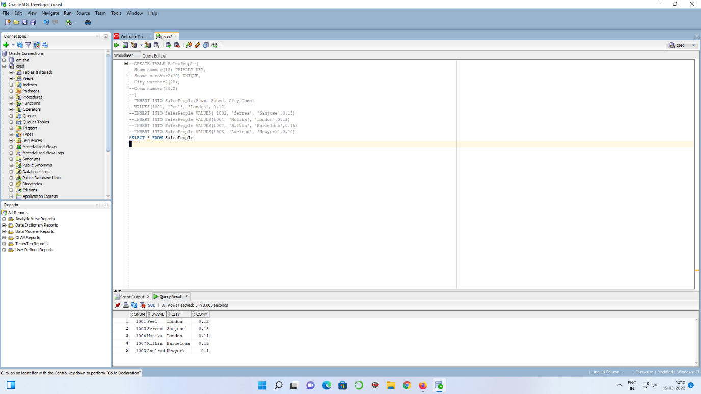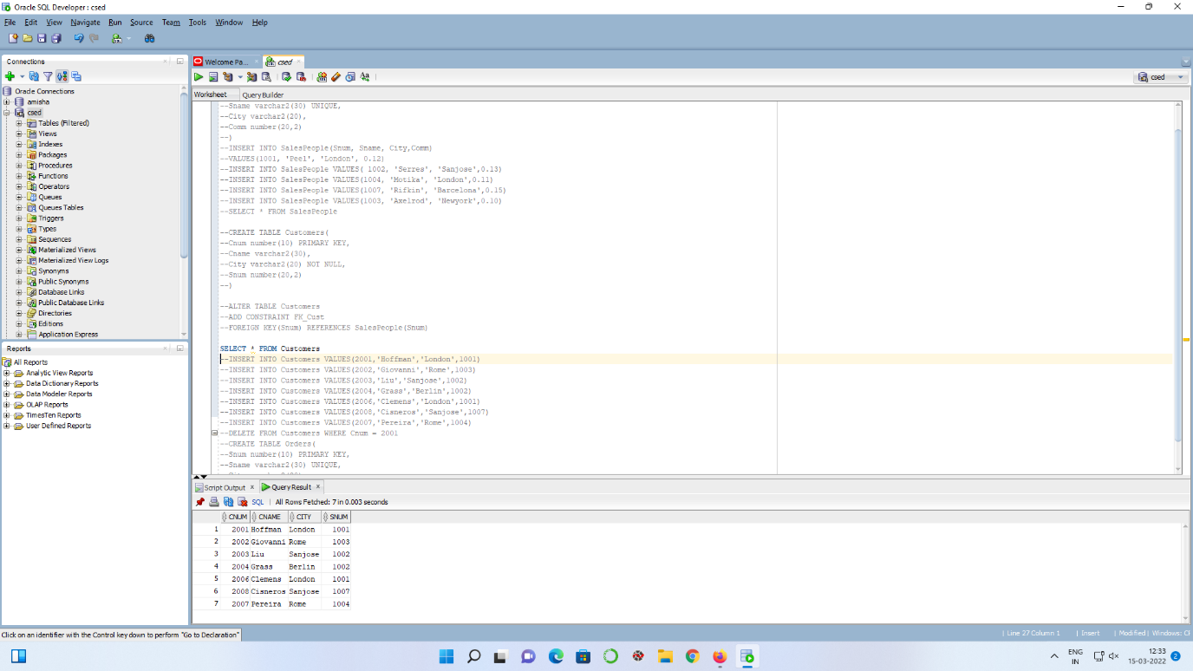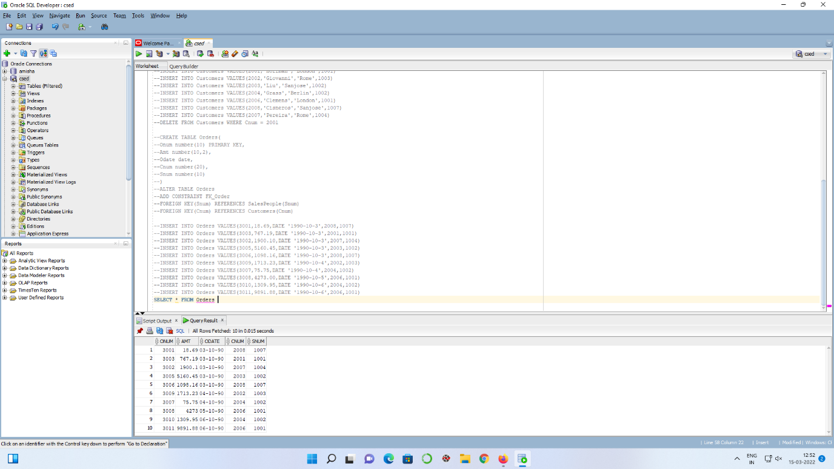

-- 1.

SELECT COUNT(*) FROM SalesPeople WHERE Sname like 'A%' or Sname like 'a%'

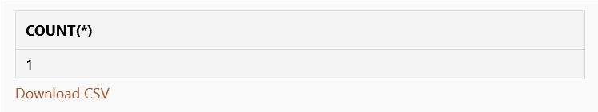

-- 2.

SELECT * FROM SalesPeople,Orders WHERE Amt>2000 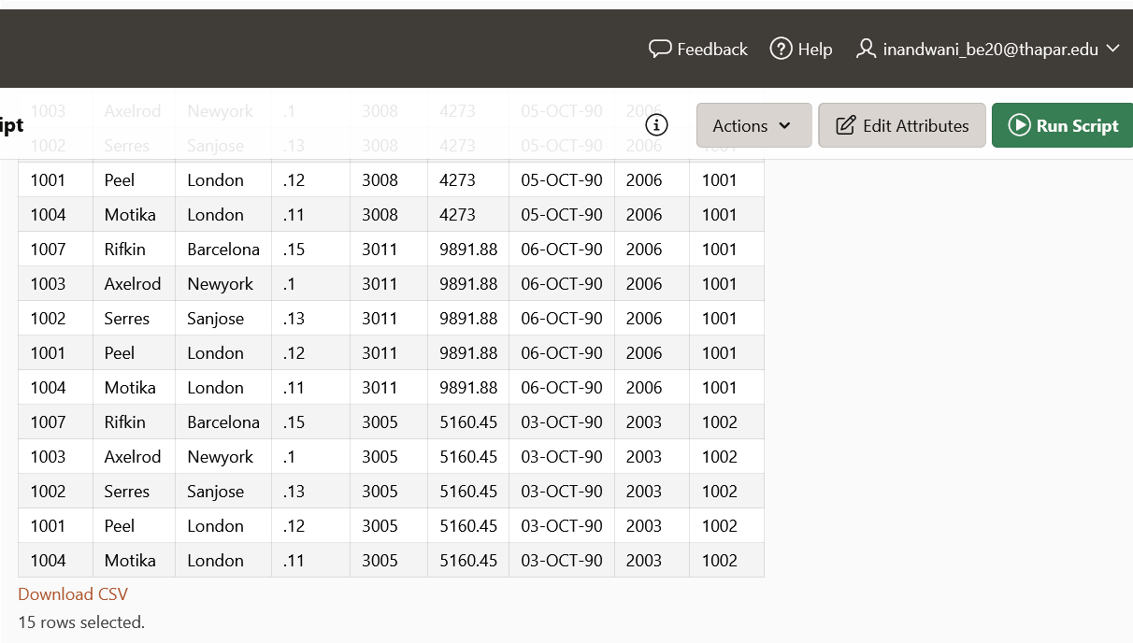

-- 3.

SELECT COUNT(*) FROM SalesPeople WHERE City='Newyork'



-- 4.

SELECT COUNT(*) FROM SalesPeople WHERE City='London' or City='Paris'

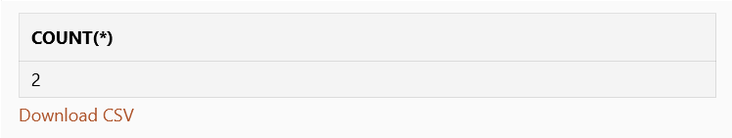

-- 5.

SELECT Snum,Count(Onum) FROM Orders Group by (Snum,Odate)

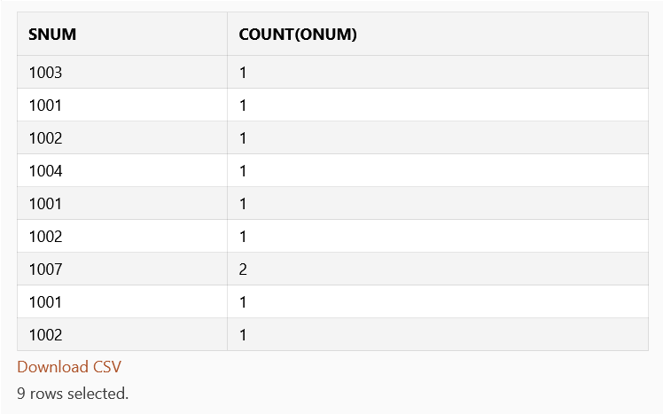

-- 6.

SELECT Odate,Count(Snum) FROM Orders GROUP BY Odate

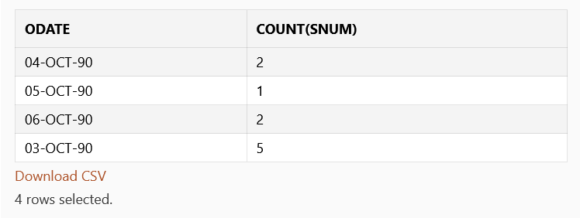

-- 7.

SELECT * FROM Customers WHERE Cname like 'G%' ORDER BY Cname

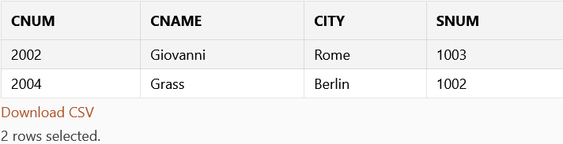

-- 8.

SELECT Snum, max(Amt) FROM Orders GROUP BY Snum having Snum=1002 or Snum=1007

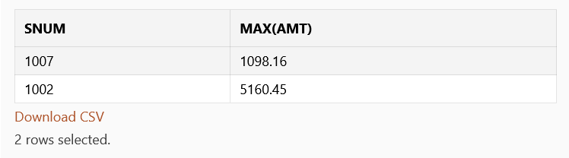

-- 9.

SELECT Snum, max(Amt),Odate FROM Orders GROUP BY (Snum, Odate) having max(Amt)>3000

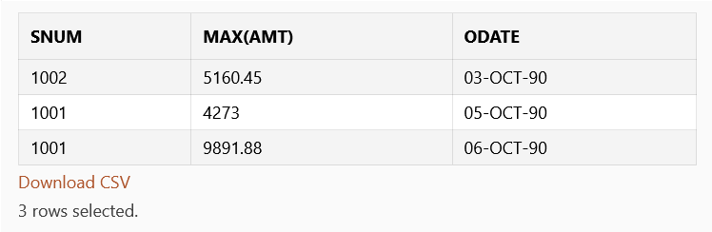

-- 10.

SELECT COUNT(Sname) FROM SalesPeople WHERE SalesPeople.city=SalesPeople.city AND SalesPeople.comm=SalesPeople.comm And SalesPeople.Snum!=Snum

